IEEE’S CONCERNED ETHICS VOLUNTEERS, THE CEV
2017 - 2020
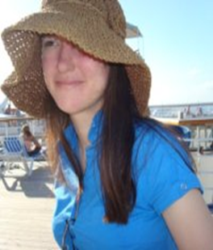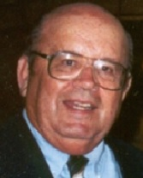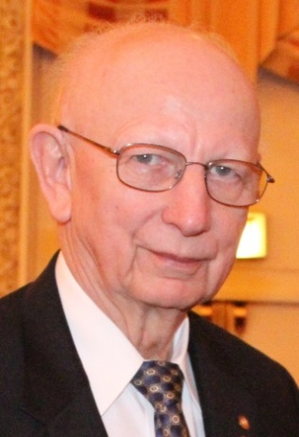
JEANETTE BARROT WALTER ELDEN RAY LARSEN
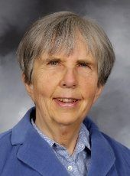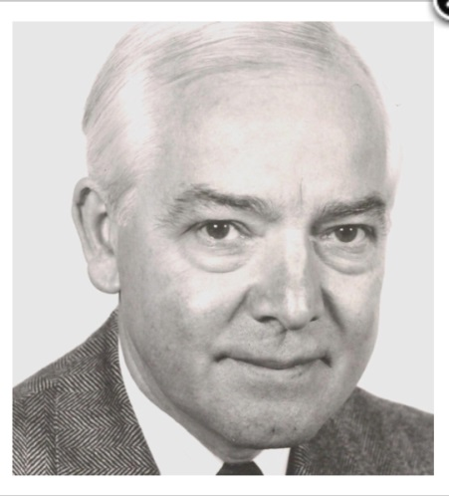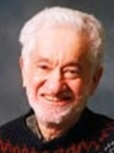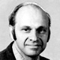
MARTHA SLOAN CHARLES TURNER STEVE UNGER VICTOR ZOURIDES

